BSX-3070 Progress Check (17th December 2025)
Complete this form and include it as the first page of your submission on Blackboard.
Name: Tobis Nunn
Student ID number: 500690571
Title of dissertation (a working title is fine): Functional adaptation of microbiotic Pseudomonas to aquatic, terrestrial, and aerial vertebrate hosts

Supervisor’s name: Aaron Comeault
Date: 17th December 2025

Please answer the following questions:
- When was your last meeting with your supervisor? Monday the 24th of November
- How many meetings have you had in semester 1? A handful, maybe 4-6
- What written work have you sent to your supervisor in advance of this progress check? Plan / draft of dissertation submission

- How did you send this written work in? If it’s been submitted separately to this form, please also note the date and subject line of any email submissions here:
17th Dec 2025 -
[fill in when done]
- How much do you agree with the statement “I feel confident that I have made enough progress on my dissertation so far”? Make a mark on the scale or write a number beside it.
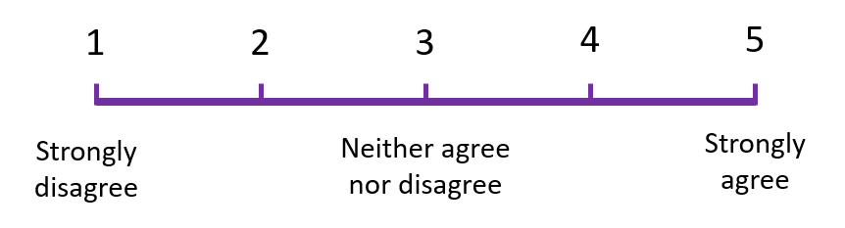

4

- How much do you agree with the statement “I have the skills I need to complete my dissertation to a standard I will be happy with, and/or have concrete plans to learn any skills I don’t yet have”? Make a mark on the scale or write a number beside it.


4

- Which skills or areas of knowledge do you still want/need to develop? (I may use this answer to add or tailor teaching sessions!) N/A


Gen-AI in assessment declaration
Student 500 number: 500690571
Module Code: BSX-3070
Assessment: Progress Check
Assessment’s Gen-AI Category (see the Assessment Brief): 2

The following statement reflects my use of Gen-AI within this assessment (select all that apply):
Description of use | Select (X)
Gen-AI has not been used at all in producing this assessment.
Gen-AI was used in an assistive role to research topics and provide explanations. | X
Gen-AI was used in an assistive role to suggest sources of information, e.g. publications to read. | X
Gen-AI was used in an assistive role to summarize the content of publications or other sources. | X
Gen-AI was used in an assistive role to produce an outline or draft structure of my assessment.  Note: for Category 2 assessments, the fundamental content of the submission (e.g., the arguments, interpretations, conclusions etc) must be your own. | X
Gen-AI was used in an assistive role to improve spelling, grammar, sentence structure and/or clarity of expression of my assessment.  Note: for Category 2 assessments, the basic written expression must be your own. Therefore, whilst Gen-AI may correct mistakes it must not produce the actual content. | X
Gen-AI was used in an assistive role to translate text during the production of the work.
Gen-AI was used in an assistive role to analyse data and/or produce visualizations of data. | X
Gen-AI was used in an assistive role to help produce creative outputs e.g. art, imagery, movie, music, creative writing.
Gen-AI was used in an assistive role to refine computer code and/or other output. | X
Gen-AI was used in another assistive role (please describe):
Gen-AI was fully used to complete a Category 3 assessment and use complied with the assessment instructions provided.

By using this cover sheet and entering my student ID above, I declare that I have provided honest and accurate details regarding my use of Gen-AI within this assessment.

